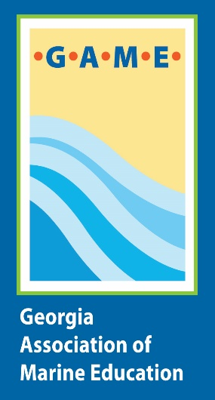
Georgia Association of Marine Education Annual Conference Scholarship Program
Applications must be submitted on or before October 15, 2022
Recipients will be notified by October 22, 202

The Georgia Association of Marine Education (GAME) envisions a collaborative community of educators, scientists, and concerned citizens. The group provides networking opportunities for its members, equips educators to teach marine science concepts more effectively, and celebrates the wonder of the aquatic systems of Georgia.

To help fulfil this mission, GAME offers scholarships to offset the cost of attending the annual conference. These scholarships cover Conference Registration (approximately a $125 value) and do not include cost of travel or lodging for the conference. All recipients are required to submit an article or classroom activity for publication in the GAME eNewsletter. Applications submitted after the October 15th deadline will not be considered. All applications will be confidential and only reviewed by the Scholarship Committee members. If the applicant is unable to attend once the scholarship is awarded, the applicant must contact Kim Morris-Zarneke immediately in order to provide an opportunity for the scholarship to be awarded to the next qualified applicant.

The following scholarships are available:
- Margaret Olson Memorial Travel Scholarship (Coastal Connections): Awarded in memory of Margaret Olson to a GAME member who made the coastal connection by bringing the coast inland if the individuals could not make their way to the coast.
- New Membership Scholarship (Expanding Audience): Awarded to an individual seeking GAME membership for the first time.
- GAME Conference Scholarship: Awarded to a current GAME member with a financial need to offset conference costs.

If you have any questions please contact Kim Morris-Zarneke@dnr.ga.gov

GAME Scholarship Application Form
Deadline: October 15, 2022

I am submitting an application for the following GAME Scholarship (select only one)

____Margaret Olson Memorial Travel Scholarship (Coastal Connections)
____New Membership Scholarship (Expanding Audience)
____GAME Conference Scholarship
Name: ____________________________________________________________________

Organization: ______________________________________________________________

Mailing Address: ___________________________________________________________
___________________________________________________________________________

Phone number: _____________________________________________________________

Email address: _____________________________________________________________

Position: ___________________________________________________________________

Are you a GAME member? Yes or No

On a separate sheet of paper, Briefly respond to the following four questions.

- Describe how you are involved in marine and aquatic education.
- Describe what specific information, skills, or contacts you will be seeking at the GAME Annual Conference and how will they be used.
- What financial circumstances require you to seek a scholarship to attend the GAME Annual Conference?
- Briefly describe any non-financial circumstances you would like the committee to consider in their decision.

TERMS of AGREEMENT

I understand that:

- I must be a GAME member at the time of the application to be eligible for either of the two membership scholarships

- I am expected to attend the full conference, taking maximum advantage of the conference sessions and field experiences offered

- I am expected to use information and skills gained at the conference to submit an article or classroom activity for submission to the GAME eNewsletter by December 15, 2022

- If awarded a scholarship, I will not be eligible for a scholarship for two subsequent GAME Annual Conferences

- If I decline to attend, the award will be forfeited and cannot be applied to any other GAME event.

I certify that all the statements made above are true and correct.

Applicant Signature: ______________________________________________________

Date:_______________________

