Plankton Races
- What’s it like to be plankton? Plankton are amazing organisms. Not only are many tremendously small, but plankton have adapted to be incredible drifters. Now that you have seen plankton, you are going to create your own drifting creature!
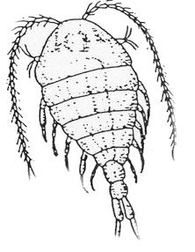
Copepod

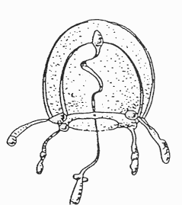
Jelly

- Here are the instructions and rules the students should follow:
- Each person will be given a small ball of clay. The goal is to create a plankton of any shape that will float on the surface of the water. Why would phytoplankton benefit from being near the surface of the water? Talk about the euphotic zone. (It is worth mentioning that in real life the plankton would not float directly on top of the water, but rather would float near the surface of the water.)
- Why is it important for the plankton to not sink? If phytoplankton sink below the euphotic zone, they do not have enough sunlight available for them to photosynthesize and will die.
- The plankton you are about to create will be put in water, so be prepared to retrieve your clay if it sinks.
- The entire ball of clay must be used to create the plankton.
- To help teach about classification and identification, have your students name their plankton.
- Tell the students that they want to create a plankton that will float.

- Give the students a few minutes to create and test their plankton in the water. When time is up, have each student test their plankton in the water to see if it floats.
- When you are all done, wrap up by talking about all the different body shapes that everyone made. If you could do this experiment over again, how would you change your plankton? Why? You should have the students who made the best floating plankton come to the front to show off their plankton and say its name. Once more, review terms and important concepts about why plankton would need to have a specially adapted body to float.

